Silver Wings unites civilians and military students
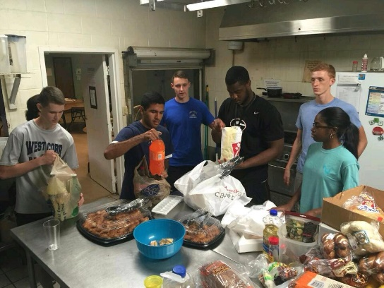
What happens when regular college students and ROTC students unite? They form Silver Wings.
Many students at the University of Georgia have heard about UGA HEROs, Relay for Life and the Athens Area Humane Society, but Silver Wings is still a mystery.
“Silver Wings helps their members develop professional skills such as public speaking and works together to serve the community,” Camilo Medina, vice-president of Silver Wings, said. “Our main goal is to support Arnold Air Society, a service organization within Air Force ROTC.”
Medina said since AAS focuses on ROTC students, Silver Wings is open to everyone.
“Silver Wings allows civilians to learn more about the military world, and at the same time ROTC students learn to work with civilians,” Medina said.
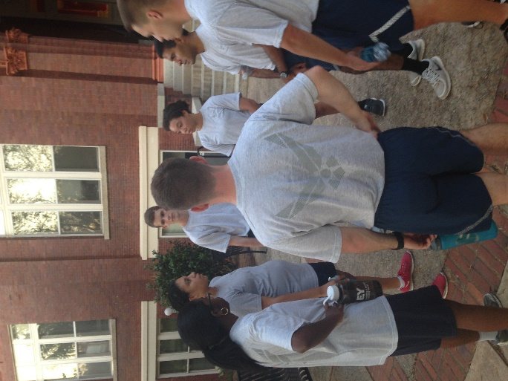
Students who wish to join Silver Wings must first experience a ten-week training. During the training, initiates learn how to build a resume, public speaking skills and parliamentary procedures. Most importantly, initiates build camaraderie with each other.
“Silver Wings is a professional environment,” Medina said. “The members refer to each other by their last names with the proper Mr. and Ms./Mrs.”
“We wouldn’t be able to function the same or accomplish our service events without the support from Silver Wings,” Ricoh Blackmon, president of AAS said. “They willingly volunteer to help the cadets, and they provide us the extra manpower. “We are always so grateful.”
Blackmon said many service organizations struggle, because they lack manpower or support from other organizations and members. Therefore, he continued to express his gratitude towards Silver Wings, and their service to AAS.
“It must be difficult handling their own affairs, but they still continued to support us,” Blackmon said.
“Silver Wings is special, because it also provides an opportunity for college students to interact with the military side of college life,” Blackmon said.
Matthew Wathen, current member of Silver Wings and also a ROTC student, said he mainly joined the organization for community service and to give back to the community.
“I decided to join Silver Wings not because I am a cadet, but Silver Wings has a special method of deciding their service projects for the semester,” Wathen said. “It’s unique.” “This semester’s theme is Helping the Homeless, so on Oct. 17, we donated food to the local homeless shelter.”
“Camilo also makes Silver Wings unique by helping us think about the deeper meaning of service,” Wathen said. “I’ve learned to be thankful for what I have in a well-established home, and it’s time that I share what I have.”
Ryan Woodall, current initiate, said Silver Wings has motivated him to serve the community. “Motivation is something most organizations lack,” he said. “However, Camilo does a good job of motivating us to serve with the right purpose.”
“I rather serve the community with Silver Wings than waste my free time playing video games or sleeping,” Woodall said.
Although Medina is the vice-president, Silver Wings members acknowledge Medina’s leadership skills. According to the president of Silver Wings and other members, they look up to him to lead the organization.
“Silver Wings is low in membership, but we are strong as a whole,” Medina said.

